***-: Food Save Application :-***

**SYSTEM OVERVIEW  
Choice of Android**Android has been chosen for this project due to open-source nature of the platform as well as the ease of development and deployment. It also has the largest market share and also supports cross platform application development, i.e., developers can develop Android application in Mac, Windows and many UNIX-based operating systems like Ubuntu.

**System Architecture**This application consists of an Android application on the client side and JAVA-MySQL application on the server side. The Android application is the part visible to the user and one it interacts with, while the JAVA/MySQL-based server-side component serves as an interface between the Android application and the database on the server.

The use case for the client-side application is shown in Figure below, showing all the cases available to the user in the application.

|  |  |
| --- | --- |
|  |  |
| Fig. Use case for client-side application | Use case for server-side implementation. |

**MVC Architecture**

The application is a hybrid mobile app having 3 layers of presentation, business logic and data, defining the basis for MVC (Model View Controller) architecture. Specifically for Android mobile app, we will use **Clean Architecture** to allow each layer working separately and independently from others, helping to adopt changes only for that particular layer without disturbing the architecture of whole system.

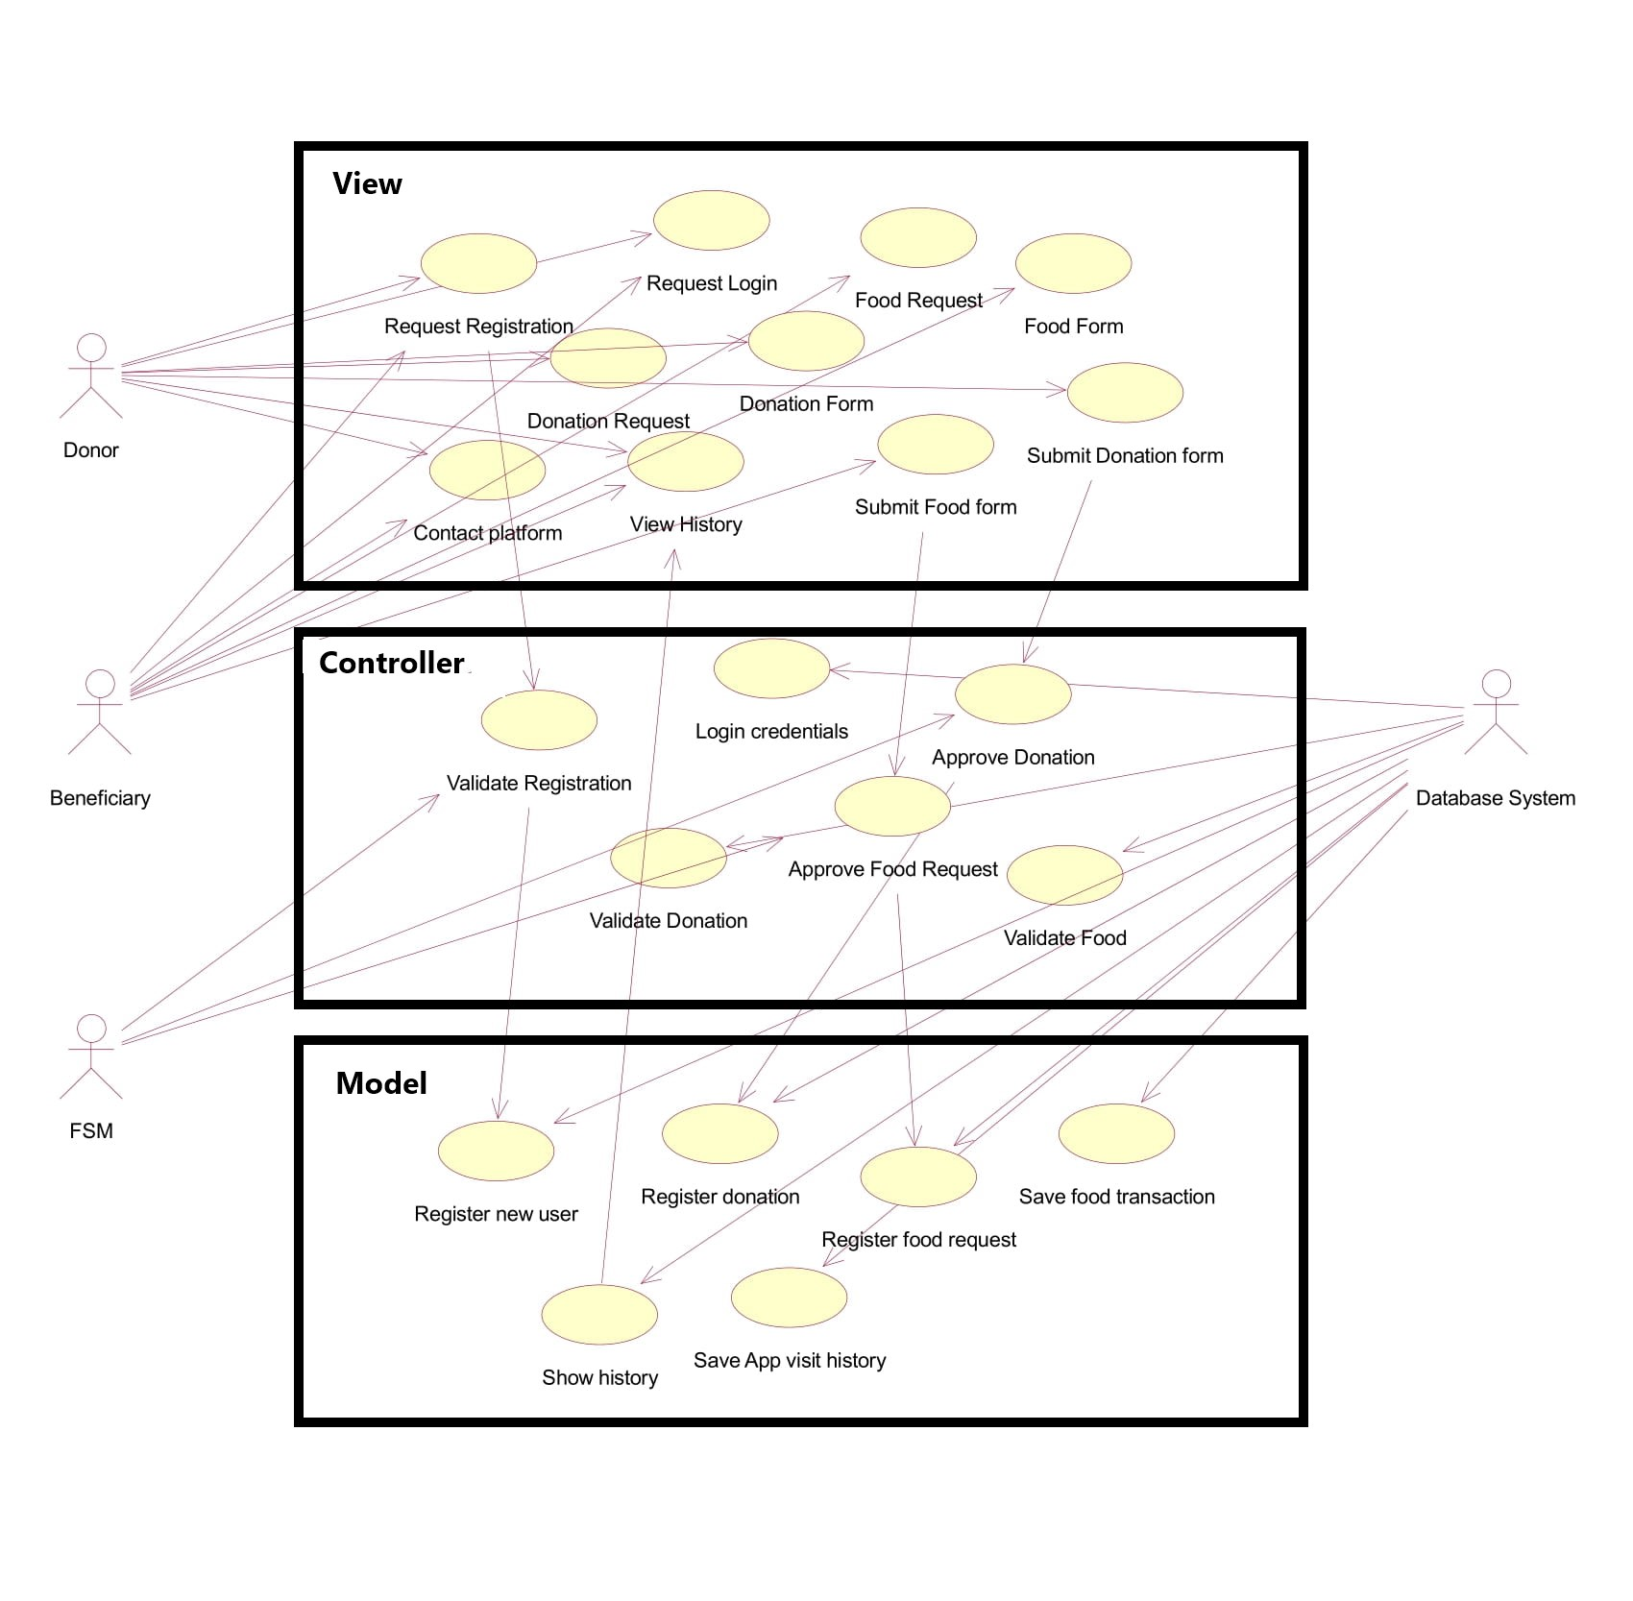

References:

<https://www.netsolutions.com/insights/mobile-app-architecture-guide/>

<https://www.toptal.com/android/benefits-of-clean-architecture-android>